15th October 2013 PRESS RELEASE

Flippa Ball launches in Joondalup

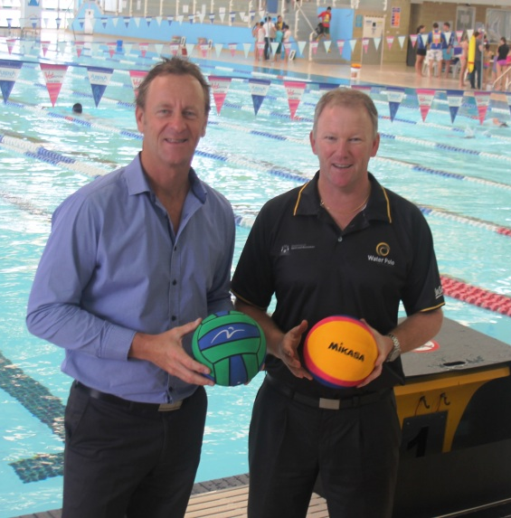
Buccaneer Swimming Pools is proud to announce their sponsorship of the Water Polo WA Flippa Ball program which begins on Thursday
17 October 2013 at Venues West Arena Joondalup. The program is designed for 8-12 year olds and is an ideal way for young kids to learn how to play Junior Water Polo.

The Flippa Ball program aims to establish Water Polo in the Northern suburbs and encourage increased participation in the sport from a young age. The program is being made possible with the help of Arena Swim Club and Venues West. Water Polo WA is engaging in strong partnerships with both entities at the Arena. Water Polo WA CEO Dale Ballantyne says ‘The Flippa Ball program is part of our strategic plan to grow the sport in a sustainable way and build capacity within venues to host the sport of Water Polo’.

Water Polo in WA has seen significant growth with overall participation rates up nearly 30% on the previous year. Flipper Ball has also seen a huge increase in interest with over 50% more signups for the same period. Water Polo WA is taking a proactive approach by introducing new programs and by building strong relationships with Local Governments, Facilities and existing user groups. The 2013/14 season has seen the introduction of Karratha Water Polo Association, North Coast Water Polo Club and now the Joondalup Flippa Ball program.

With the help of Buccaneer Swimming Pools, one of Australia’s most established swimming pool companies, Water Polo WA can help build the Joondalup Flippa Ball program from the ground up. Their sponsorship will provide new equipment, venue hire and development opportunities by allowing Water Polo WA to secure top coaches and referees.

Buccaneer Swimming Pools Brand Manager Andrew Farmer is excited about the partnership and says “The sponsorship of Water Polo WA’s Flippa Ball program in Joondalup is a natural fit for both parties. The sponsorship allows the Buccaneer Swimming Pools brand to be associated with families with small children who are keen on being involved in a fit and healthy aquatic sport.”

Starting back in 1968, Buccaneer Swimming Pools celebrate over 40 years of business in WA. With a wide range of fibreglass pools built to Australian Standards, they are committed to providing the best lifestyle package and value for money to their customers. They have three conveniently located display centres across Perth, including one in the Joondalup business centre.

Registrations are now open for the Flippa Ball program at Venues West Arena Joondalup, which runs from 17 October 2013 - 15 December 2013, Thursday 6:00pm and Sunday 2:30pm. Contact Water Polo WA on (08) 9387 7555 for more information.

Image: Buccaneer Swimming Pools Brand Manager Andrew Farmer (left) and Water Polo WA CEO Dale Ballantyne (right) at Venues West Arena Joondalup.

End

Contacts:
Larissa Lively - Marketing Coordinator Dale Ballantyne
Aquatic Leisure Technologies CEO – Water Polo WA Inc
Ph: (08) 9282 9065 Ph: (08) 9387 7555
Email: llively@aqualeisure.com.au Email: Dale.Ballantyne@waterpolowa.asn.au

